Breakthrough and Drafting

1. Introduction and literature review; the goal of your research

From the rising levels of the greenhouse gas emissions into the atmosphere to the extinction of energy sources to the rising global temperature of the overall Earth to the rising sea level to the more intense/extreme natural disasters to the raging wildfires, climate change is a serious and severe issue that poses an inhumane threat and dire consequences; the issue will only exacerbate as time goes on to the point where the damage can’t be reversible. Thus, we have to start taking action TODAY! Data visualization is going to be more helpful to achieve my goal of combatting climate change since there are not one, but many/multiple factors I can focus on/highlight in various visualizations to help communicate my goal across more effectively. Moreover, I have decided to use the method of communicating the various trends of the aspect(s) of climate change through various graphs and plots using pleasing aesthetic which are eyecatching. Because visualizations tend to catch the attention of people right away (instead of throwing out alarming facts/statistics – which can be seen as random, meaningless to people who don’t have prior knowledge on the subject), I am hoping that data visualizations will drive the point of taking drastic action NOW to save our Earth since everyone has common knowledge of looking at, and interpreting pictures/trends

1. Data that you used – description and summary

The dataset, historical_emissions, contains 33 columns and 196 rows. The historical_emissions dataset applies the same methodology to create a six-gas, multi sector and internationally comparable dataset for 196 countries. It allows users to use data by filtering/grouping the data by year, gas, country/state and sector.

1. Methods used – what worked, what didn’t work

I have created 3 visualizations in tableau in hopes that people realize the extremity of the threat that climate change poses. The interactive bubble plot didn’t work, but I hope that the 3 visualizations drive the point home!

1. Results

**1st visualization: World Map of all Countries GHG Emissions in 2017**

* This world map shows all the current GHG emissions by country in 2017. From the map, I can make out that China, Russia, Canada, Brazil, Argentina, India and the U.S. are the seven countries that emit a ton of GHG emissions into the world in comparison to other countries (they are shaded in as medium blue, blue and dark blue). This portrays a message that they need to start taking action now before it becomes worse and they should learn from other countries/adopt their practices who’s GHG emissions aren’t as high (indicated by the gray/faint blue color).

**2nd visualization: Side by Side Bar Chart of Top 10 Countries that Emit GHG Emissions (2007 vs 2017)**

* + This side by side bar chart shows the top 10 countries in the world that emit the most GHG emissions and shows how much their GHG emissions have increased or decreased from 2007 (blue) – 2017 (orange). In addition, the side by side bar chart shows how good the world is doing by displaying total GHG emissions in 2007 total GHG emissions in 2017
  + From the plot, I can make out that most of the countries are doing fairly well in keeping their GHG emissions down in comparison to China (whose levels have risen up about 3000 in the last years) and if we want to be critical, India too! The thing that scares me the most is that the World is doing so poorly trying to reduce their GHG emissions; to the point where it went from about 45,000 in 2007 to around 50,000 in 2017! This indicates that the world (all countries collectively) have to take immediate action now if they want this trend to change and decrease.

**3rd visualization: GHG Emissions from 1990-2017 of Top 5 Countries**

* + This side by side bar chart shows GHG emissions of Top 5 Countries over the span of 27 years. Each year is color coded to make it easier for comparison (if you want to compare levels of that particular year among other countries) and for presentation purposes. From this side by side bar chart, I can make out that the European Union as well as Russia are trying to keep their GHG levels down over the years while China and India are failing to do so over the years. This side by side bar chart shows the top 5 countries in the world that emit the most GHG emissions and shows how much their GHG emissions have increased or decreased from 2007-2017. In addition, the side by side bar chart shows how good the world is doing by displaying total GHG emissions in 2007 total GHG emissions in 2017. Even though the United States is trying to keep their numbers down and in range, their GHG levels in comparison to Russia and the European Union (especially are about 2000-3000 more higher)! Even though U.S. is trying to keep their levels from not going too high, the main thing they should work on is trying to bring them down significantly first before maintaining the levels.

1. Visualization of results

**1st visualization: World Map of all Countries GHG Emissions in 2017**

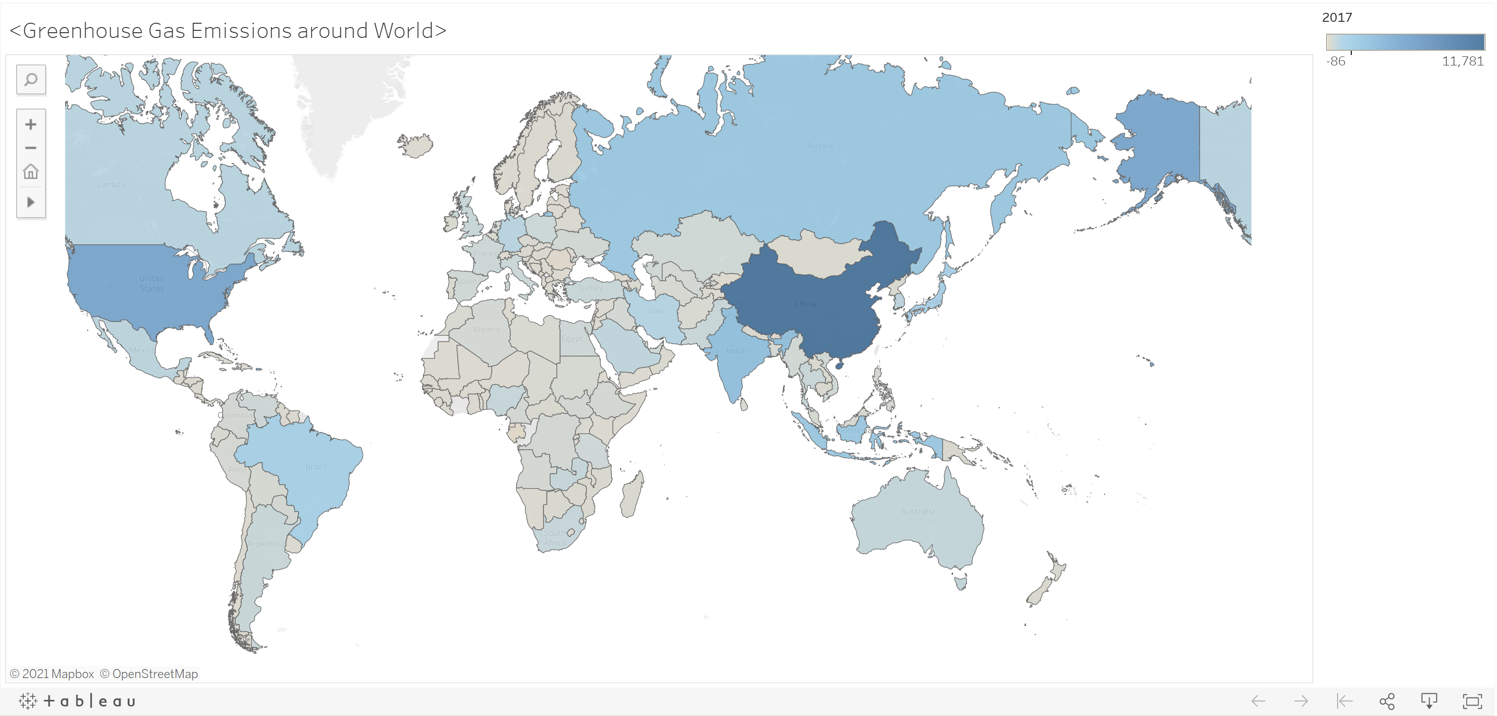

**2nd visualization: Side by Side Bar Chart of Top 10 Countries that Emit GHG Emissions (2007 vs 2017)**

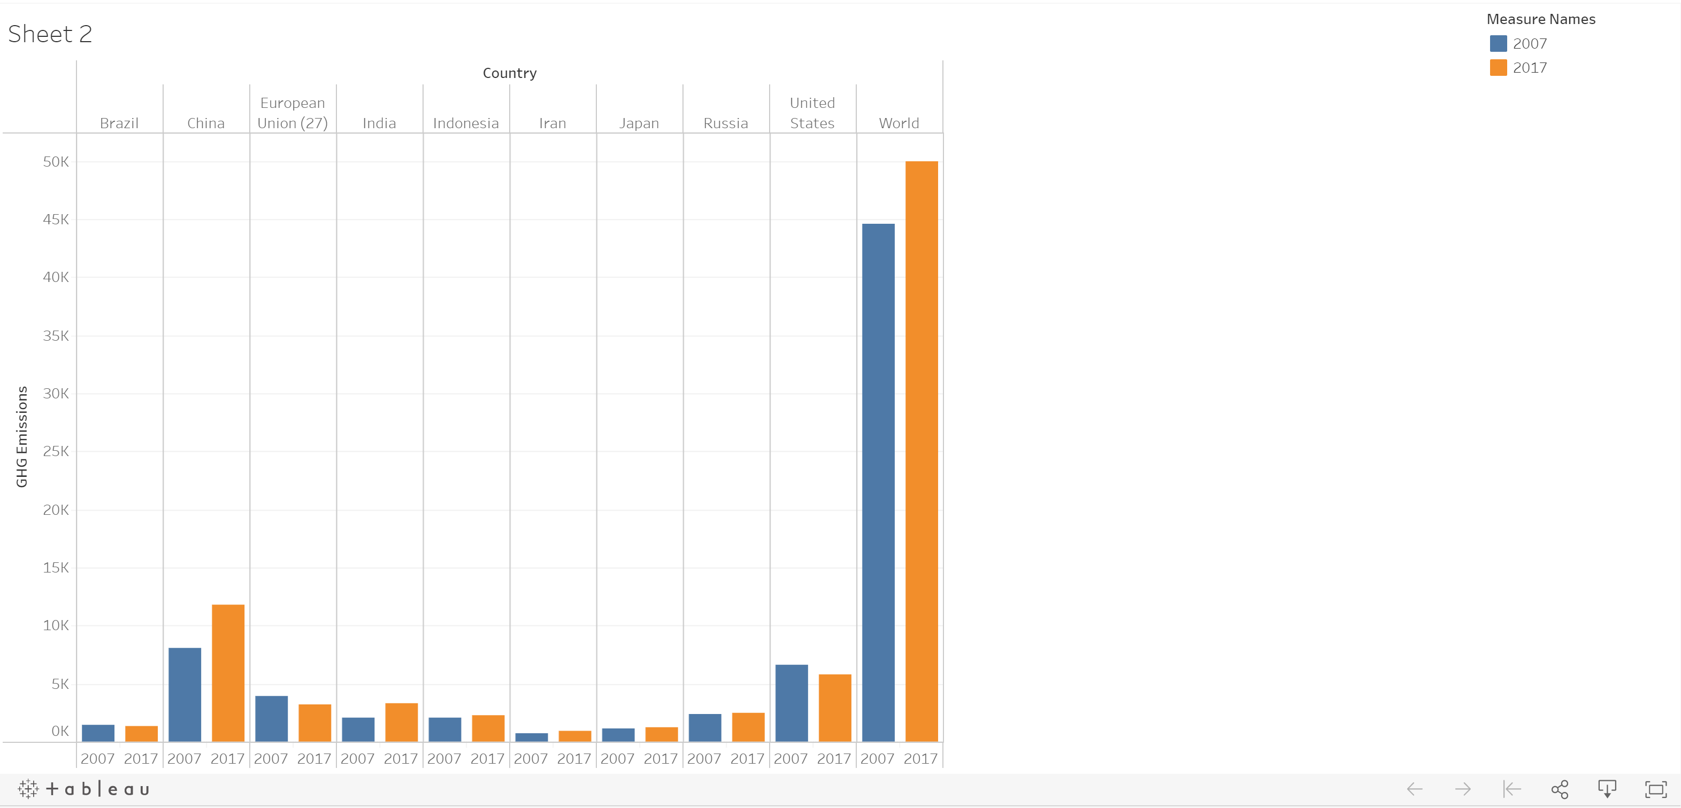

**3rd visualization: GHG Emissions from 1990-2017 of Top 5 Countries**

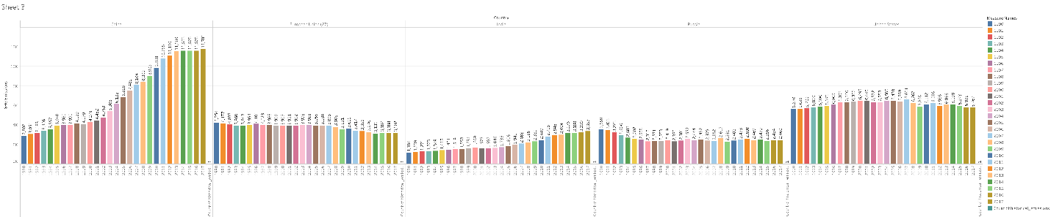

1. Conclusion

Climate Change is the defining issue of our time and without drastic action today, adapting to the impacts of climate change in the future will eventually be next to impossible and costly. We have a moral obligation to preserve our climate for future generations. Even though greenhouse gases occur naturally and are essential to the survival of humans and other species, the cumulative level of greenhouse gas emissions increases as our population, economies, standards of living, industrialization, deforestation and/or large scale agriculture increases.

Climate change is a serious and severe issue that poses an inhumane threat and dire consequences; the issue will only exacerbate as time goes on to the point where the damage can’t be reversible. Thus, we have to start taking action TODAY!

Just acknowledging climate change isn’t enough. I would strongly encourage everyone believes in the science of climate change. Climate change isn’t going anywhere, humans are responsible for climate change and the problem will only exacerbate if we keep ignoring/denying that it is currently happening.

Even if people have predetermined biases on climate change and deny that climate change is happening, it is critical to realize the extremity of the threat that climate change poses (by looking at the 3 visualizations that sum up the GHG emissions – 1 aspect of climate change) and take action NOW!

I suggest that the U.S. starts by allocating a budget for the climate change issue, funding environmental agencies and environmental regulations through bills and also support acts and pass them through the house of representatives.

All other problems in comparison to climate change (such as police brutality, racism, pandemics, etc) are little; we have to first make the earth livable and solve the overall big problem of climate change before we can even think about solving other problems. In other words, we can’t solve other problems within our communities/globally if the Earth is destroyed/has an inhumane environment.